##### Business Developer Tool

**Description:** Each global ultimate parent account or single company on the org has two user lookup named business developer 1 and 2. This component lets the user set them, edit them or delete them massively. Only the Client Program Global accounts are searched, as indicated in the US acceptance criteria.

Right now, to maintain these business developers, they are stored in an object named *Business Developer*. A Batch process that should run every hour, search for changes on these records to set/update/delete the accounts that match. The business developer record creations works as following:

To create a Business developer record in the component, a user should be selected in the *Employee Name* lookup, once selected, the section *Create/Edit Business Developper* should be opened. Then, a related responsibility must be selected and works as explained:

* Crown Jewel: When selecting this a lookup named *Account* is displayed. Whenever an account is selected from here, is added to the table displayed bellow the other fields. After saving, all the account ids are stored in the *Records* field (Deal_Records__c). Once the Batch process runs, those accounts stored in the *Records* field and whose *Client Program Global* is *Crown Jewel,* will have its *Business Developer* 1 or 2 filled with the *Employee Name* user selected.
* Top Client: When selecting this the *SIC Code* component is displayed to let the user select a Branch. After saving, the Branch id is stored in the *Branch* field (Deal_Branch__c). Once the Batch process runs, those accounts whose *Client Program Global* is *Top Client* and its Branch is the one selected*,* will have its *Business Developer* 1 or 2 filled with the *Employee Name* user selected.
* Deloitte Private: When selecting a lookup named *Region* is displayed. After saving, the Region id is stored in the *Region*  field (Deal_Region__c). Once the Batch process runs, those accounts whose *Client Program Global* is *Deloitte Private* and its Region is the one selected*,* will have its *Business Developer* 1 or 2 filled with the *Employee Name* user selected.

When saving the Business Developer record, an account is searched that matches the business developer criteria and is taken as a sample account to look if it has any Business Developer lookup empty (all accounts that match the criteria should have the same values on those lookups). If no Business Developer lookup is empty, the system should show a message asking the user to edit an existing business developer or to delete it.

To edit or delete business developer records, after selecting a user in the *Employee Name* lookup, it will display all the existing records in the ‘*Business Developer Records*’ section. After selecting the desire record, it will be available to edit in the *Create/Edit* section.

**User story:** US-4839.

**Triggers:** A batch process that runs every hour and search for changes on Business Developer records.

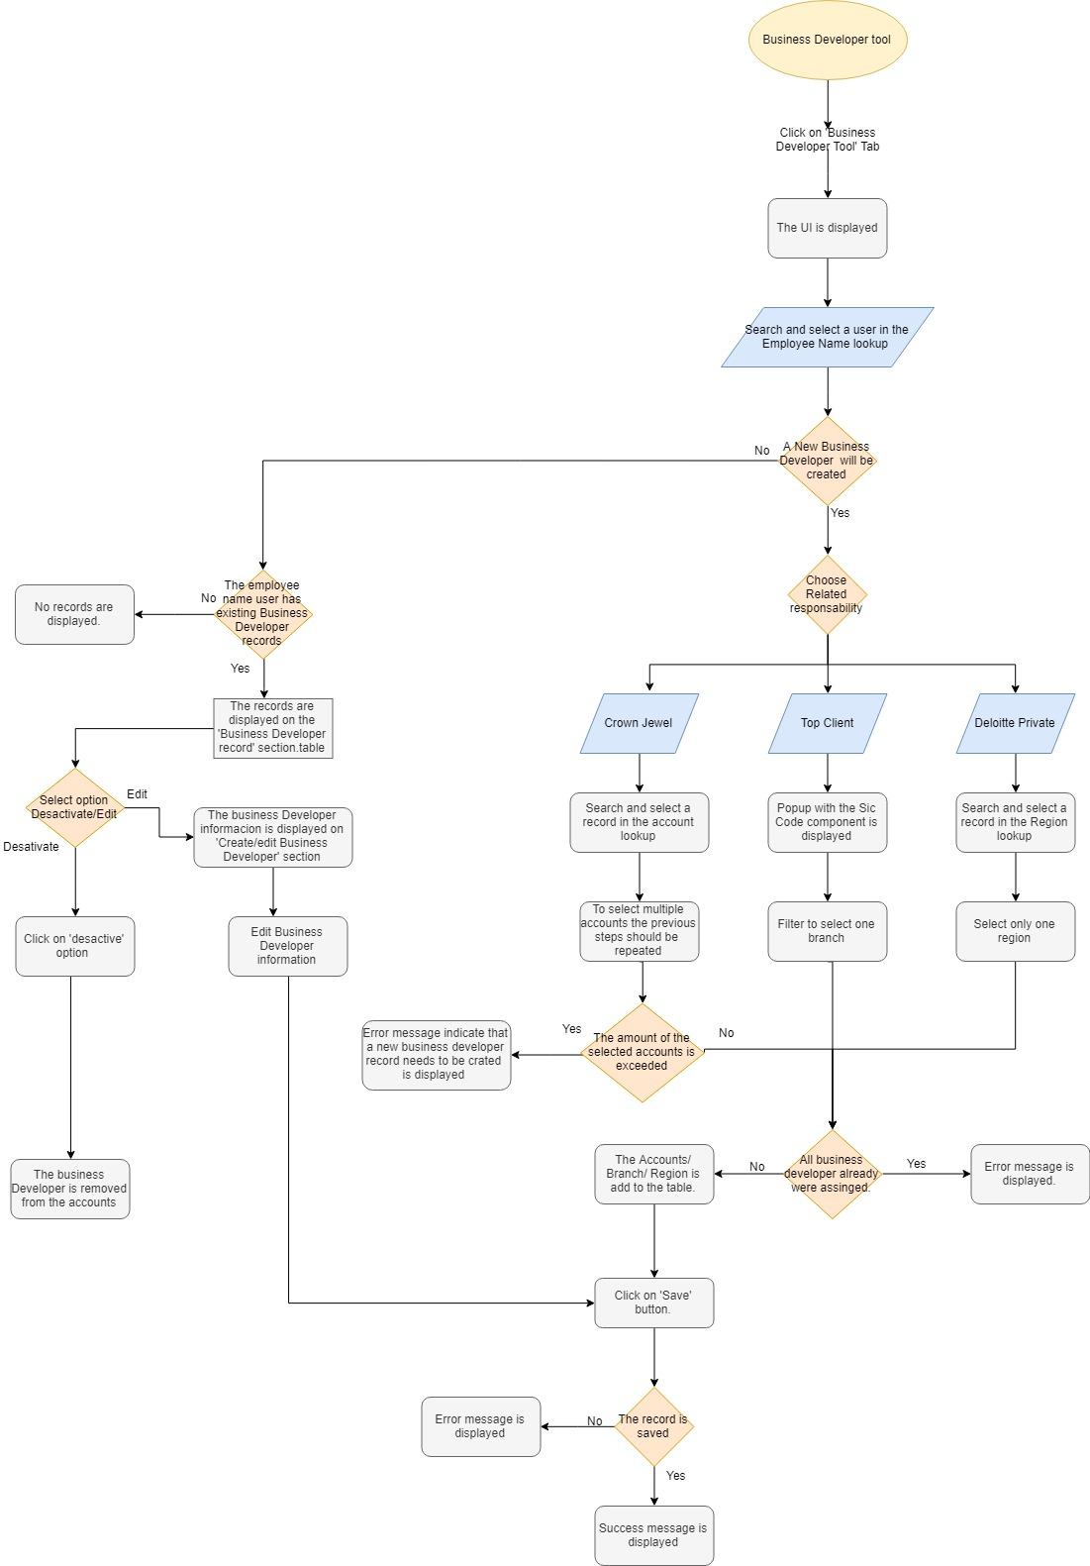

**Medadata:**

|  |  |
| --- | --- |
| Type | Name |
| Objects and Fields | **Account** (fields: DEAL_BusinessDeveloper1 __c, DEAL_BusinesDeveloper2__c). **DEAL_Branch__c** (Id). **DEAL_Region__c** (Id).  **DEAL_BusinessDeveloper__c**  Fields:  DEAL_Active__c  DEAL_Branch__c  DEAL_EmployeeName__c  DEAL_Note__c  DEAL_Records__c  DEAL_Region__c  DEAL_RelatedResponsibility__c |
| Lightning component | DEAL_BusinessDeveloperTool__c, DEAL_EmployeeNameEvent, DEAL_BusinessDeveloperRecords, DEAL_dynamicLookup. |
| Apex class | DEAL_BusinessDeveloperController, DEAL_DynamicLookup. |